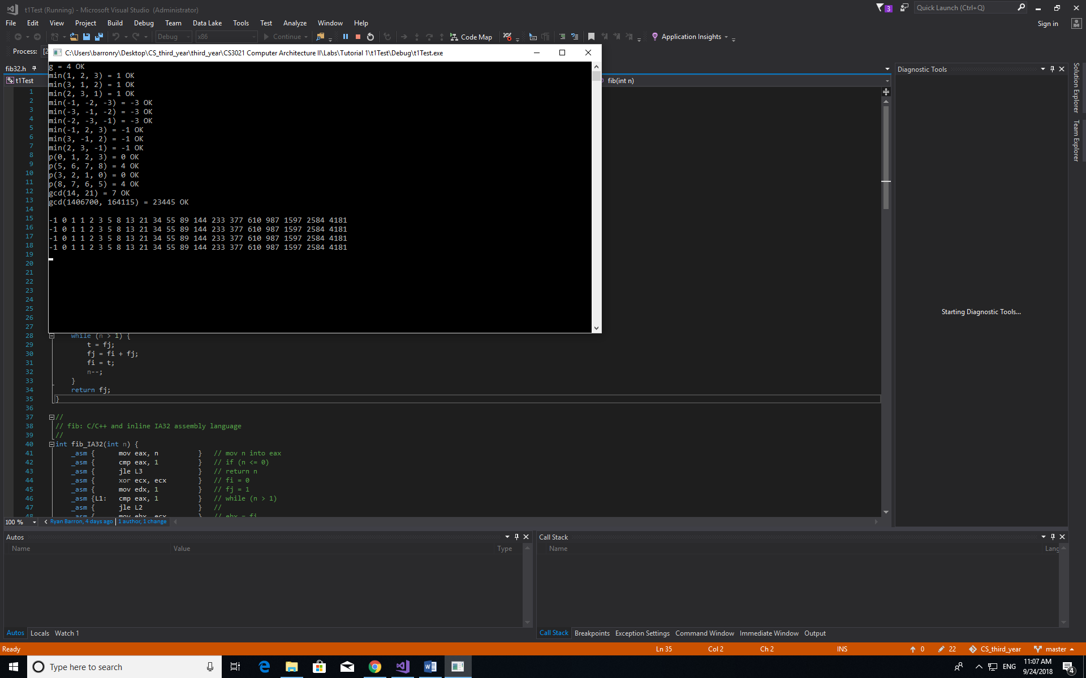

1)Calling code for min:

min(1, 2, 2);

00A927BE push 2

00A927C0 push 2

00A927C2 push 1

00A927C4 call min (0A91005h)

00A927C9 add esp,0Ch

Calle code for min:

int min(int a, int b, int c) {

00A926D0 push ebp

00A926D1 mov ebp,esp

00A926D3 sub esp,0CCh

00A926D9 push ebx

00A926DA push esi

00A926DB push edi

00A926DC lea edi,[ebp-0CCh]

00A926E2 mov ecx,33h

00A926E7 mov eax,0CCCCCCCCh

00A926EC rep stos dword ptr es:[edi]

int v = a;

00A926EE mov eax,dword ptr [a]

00A926F1 mov dword ptr [v],eax

if (b < v)

00A926F4 mov eax,dword ptr [b]

00A926F7 cmp eax,dword ptr [v]

00A926FA jge min+32h (0A92702h)

v = b;

00A926FC mov eax,dword ptr [b]

00A926FF mov dword ptr [v],eax

if (c < v)

00A92702 mov eax,dword ptr [c]

00A92705 cmp eax,dword ptr [v]

00A92708 jge min+40h (0A92710h)

v = c;

00A9270A mov eax,dword ptr [c]

00A9270D mov dword ptr [v],eax

return v;

00A92710 mov eax,dword ptr [v]

}

00A92713 pop edi

00A92714 pop esi

00A92715 pop ebx

00A92716 mov esp,ebp

00A92718 pop ebp

}

00A92719 ret

Caller code for p:

00A928EF push 0

00A928F1 push 3

00A928F3 push 2

00A928F5 push 1

00A928F7 push 0

00A928F9 call p (0A910D7h)

00A928FE add esp,10h

Callee code for p:

int p(int i, int j, int k, int l) {

00A92730 push ebp

00A92731 mov ebp,esp

00A92733 sub esp,0C0h

00A92739 push ebx

00A9273A push esi

00A9273B push edi

00A9273C lea edi,[ebp-0C0h]

00A92742 mov ecx,30h

00A92747 mov eax,0CCCCCCCCh

00A9274C rep stos dword ptr es:[edi]

return min(min(g, i, j), k, l);

00A9274E mov eax,dword ptr [l]

00A92751 push eax

00A92752 mov ecx,dword ptr [k]

00A92755 push ecx

00A92756 mov edx,dword ptr [j]

00A92759 push edx

00A9275A mov eax,dword ptr [i]

00A9275D push eax

00A9275E mov ecx,dword ptr [g (0A9C000h)]

00A92764 push ecx

00A92765 call min (0A91005h)

00A9276A add esp,0Ch

00A9276D push eax

00A9276E call min (0A91005h)

00A92773 add esp,0Ch

}

00A92776 pop edi

00A92777 pop esi

00A92778 pop ebx

}

00A92779 add esp,0C0h

00A9277F cmp ebp,esp

00A92781 call __RTC_CheckEsp (0A91172h)

00A92786 mov esp,ebp

00A92788 pop ebp

00A92789 ret

Caller code for gcd:

00A9296F push 7

00A92971 push 15h

00A92973 push 0Eh

00A92975 call gcd (0A91032h)

00A9297A add esp,8

Calle code for gcd:

int gcd(int a, int b) {

00A92610 push ebp

00A92611 mov ebp,esp

00A92613 sub esp,0C0h

00A92619 push ebx

00A9261A push esi

00A9261B push edi

00A9261C lea edi,[ebp-0C0h]

00A92622 mov ecx,30h

00A92627 mov eax,0CCCCCCCCh

00A9262C rep stos dword ptr es:[edi]

if (b == 0) {

00A9262E cmp dword ptr [b],0

00A92632 jne gcd+2Bh (0A9263Bh)

return a;

00A92634 mov eax,dword ptr [a]

00A92637 jmp gcd+3Fh (0A9264Fh)

}

else {

00A92639 jmp gcd+3Fh (0A9264Fh)

return gcd(b, a % b);

00A9263B mov eax,dword ptr [a]

00A9263E cdq

00A9263F idiv eax,dword ptr [b]

00A92642 push edx

00A92643 mov eax,dword ptr [b]

00A92646 push eax

00A92647 call gcd (0A91032h)

00A9264C add esp,8

}

}

00A9264F pop edi

00A92650 pop esi

00A92651 pop ebx

00A92652 add esp,0C0h

00A92658 cmp ebp,esp

00A9265A call __RTC_CheckEsp (0A91172h)

00A9265F mov esp,ebp

00A92661 pop ebp

00A92662 ret

Code generated with release version:

Caller code for min:

2)Stack